XCP Pro software upgrade instruction
Operate steps:
- Cut the PLC power.

- Open the folder "enrollment", then double-click "Enrollment.bat". The following two dialog box will pop up, all click "OK" to enroll.
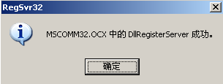
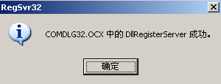

- Open the folder "System upgrade tool", doeble-click  icon.

- The upgrade window will pop up.
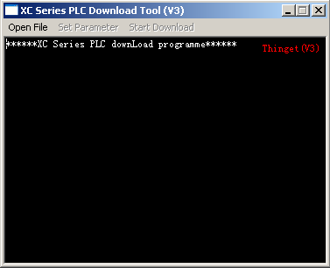
Click here to open file

- Click "Open File", choose the PLC model for upgrading (take XC3-32 for example).
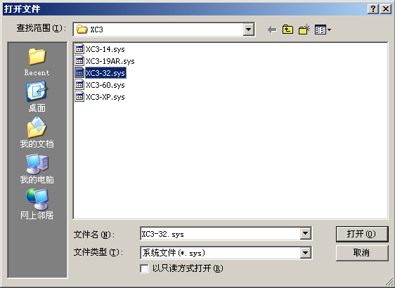
Note:No 24, 48 points PLC in the list, so take XC-32,60 points instead of XC-24,48. It should be note that after upgrade, in the XCP software, you should choose XC3-32, 60, not XC3-24,48! However, the function will be still XC3-24,48!

- Click "Set Paramenter"
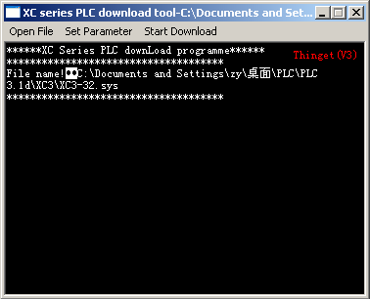
Click here to set parameter
- The "Download settings" window will pop up, do interrelated paramenter settings.
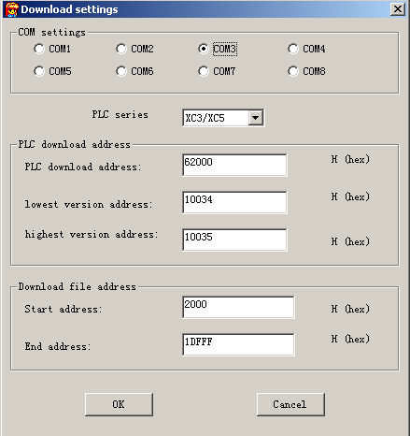
Note:If the COM port is changed,you should cut the PLC power and give it power again.

- Click "Start Download".
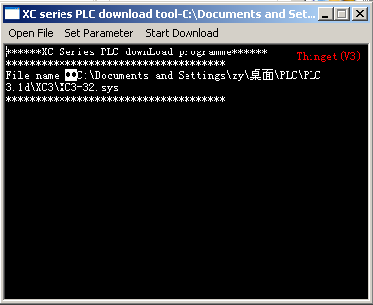
Click here to start download

- Give the PLC power, upgrading.
Note: don't cut the power during the upgrading process.

- When upgrading succeeded, please cut the power, and give it power again.

- All the upgrade is over.

